TABLE OF CONTENTS
1.0 Introduction ...................................................... 1

1.1 Background of the Study ........................................... 2

1.2 Problem Statement ................................................. 3

1.3 Aim of the Project ............................................... 3

1.4 Objectives of the Study ........................................... 4

1.5 Significance of the Study ......................................... 4

2.0 Literature Review ................................................ 5

2.1 Database Management Systems ....................................... 5

2.2 Healthcare Information Systems .................................... 6

2.3 Importance of Electronic Medical Records .......................... 7

2.4 Summary of Literature Review ...................................... 8

3.0 System Analysis and Design ........................................ 9

3.1 System Requirements ............................................... 9

3.1.1 Hardware Requirements ........................................... 9

3.1.2 Software Requirements ........................................... 10

3.2 Database Design ................................................... 10

3.2.1 Patient Table ................................................... 11

3.2.2 Appointment Table ............................................... 11

3.2.3 Visit Table ..................................................... 12

3.2.4 Health Worker Table ............................................. 12

3.2.5 Diagnosis Table ................................................. 13

3.2.6 Treatment Table ................................................. 13

3.3 Relationship Analysis ............................................. 14

3.4 Physical Data Model ............................................... 15
4.0 System Implementation ............................................. 16

4.1 Database Creation ................................................. 16

4.2 SQL Operations Used ............................................... 17

4.2.1 INSERT Statement ............................................... 17

4.2.2 SELECT Statement ............................................... 18

4.2.3 UPDATE Statement ............................................... 18

4.2.4 DELETE Statement ............................................... 19

4.3 Sample Data Entry ................................................ 20

4.4 Screenshots of Database Tables .................................... 21

5.0 Conclusion ....................................................... 22

5.1 Recommendations ................................................... 23

References ............................................................ 24

Appendix A: Physical Data Model ....................................... 25

Appendix B: SQL CREATE TABLE Statements ............................... 26

Appendix C: SQL INSERT Statements ..................................... 28

Appendix D: Sample Query Results ...................................... 30

Appendix E: Database Screenshots ...................................... 32

1.0 Introduction
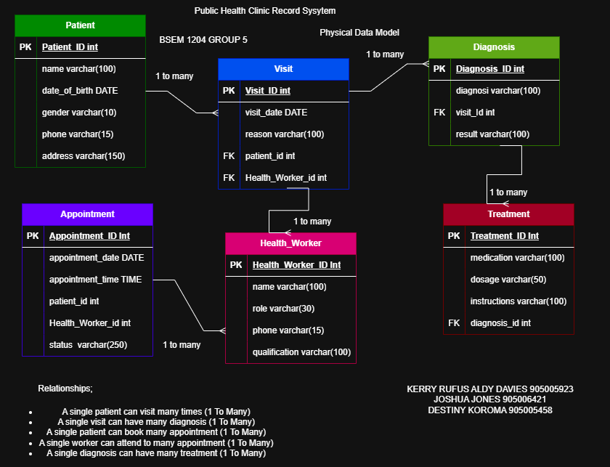
The Public Health Clinic Records System is a database management system developed to improve the storage, retrieval, and management of patient information within a clinic environment. Traditionally, patient records are maintained manually, leading to challenges such as loss of records, duplication of information, and difficulty in accessing patient history.

This project provides a computerized solution that enables healthcare workers to efficiently manage patient records, appointments, visits, diagnoses, and treatments. The system uses a relational database structure to ensure data integrity, consistency, and security.

1.1 Background of the Study

Healthcare facilities generate large amounts of patient information daily. Managing these records manually is time-consuming and prone to errors. A database-driven clinic records system helps healthcare providers maintain accurate information and improve service delivery.

1.2 Problem Statement

Many clinics still rely on paper-based record systems which result in:

- Loss of patient records.
- Difficulty retrieving patient information.
- Duplicate patient entries.
- Poor appointment management.
- Inaccurate treatment tracking.

1.3 Aim of the Project

To design and implement a database system that manages clinic records efficiently.

1.4 Objectives

The objectives of the project are:

- To store patient information securely.
- To manage appointments.
- To record patient visits.
- To store diagnoses made by healthcare workers.
- To track treatments prescribed.
- To maintain healthcare worker information.

1.5 Significance of the Study

The system helps:

- Improve record management.
- Reduce data redundancy.
- Increase efficiency.
- Enhance patient care.
- Improve decision-making.

2.0 Literature Review

Database systems are widely used in healthcare institutions to manage patient records and support medical operations.

A Database Management System (DBMS) is software that enables users to create, maintain, and control access to databases. Examples include MySQL, Oracle, SQL Server, and PostgreSQL.

Healthcare information systems provide:

- Electronic patient records.
- Appointment scheduling.
- Medical history tracking.
- Treatment management.

The Public Health Clinic Records System is built using MySQL to provide these functionalities.

3.0 System Analysis and Design

3.1 System Requirements

Hardware Requirements

- Computer System
- Minimum 4GB RAM
- 100GB Storage

Software Requirements

- MySQL
- phpMyAdmin
- XAMPP
- Web Browser
- Windows Operating System

3.2 Database Design

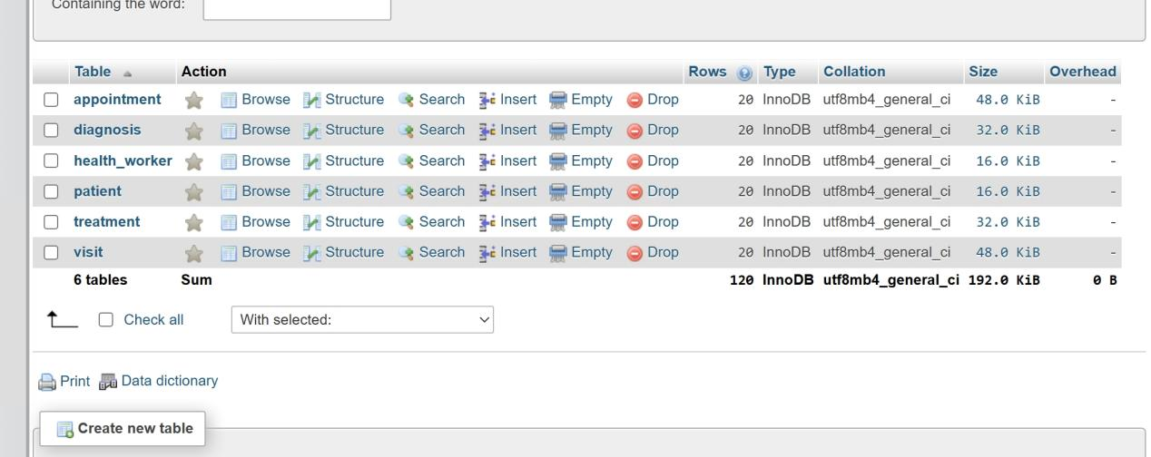

The system consists of six main tables:

Patient

Stores patient information.

Attributes:

- Patient_ID (Primary Key)
- Name
- Date_Of_Birth
- Gender
- Phone
- Address

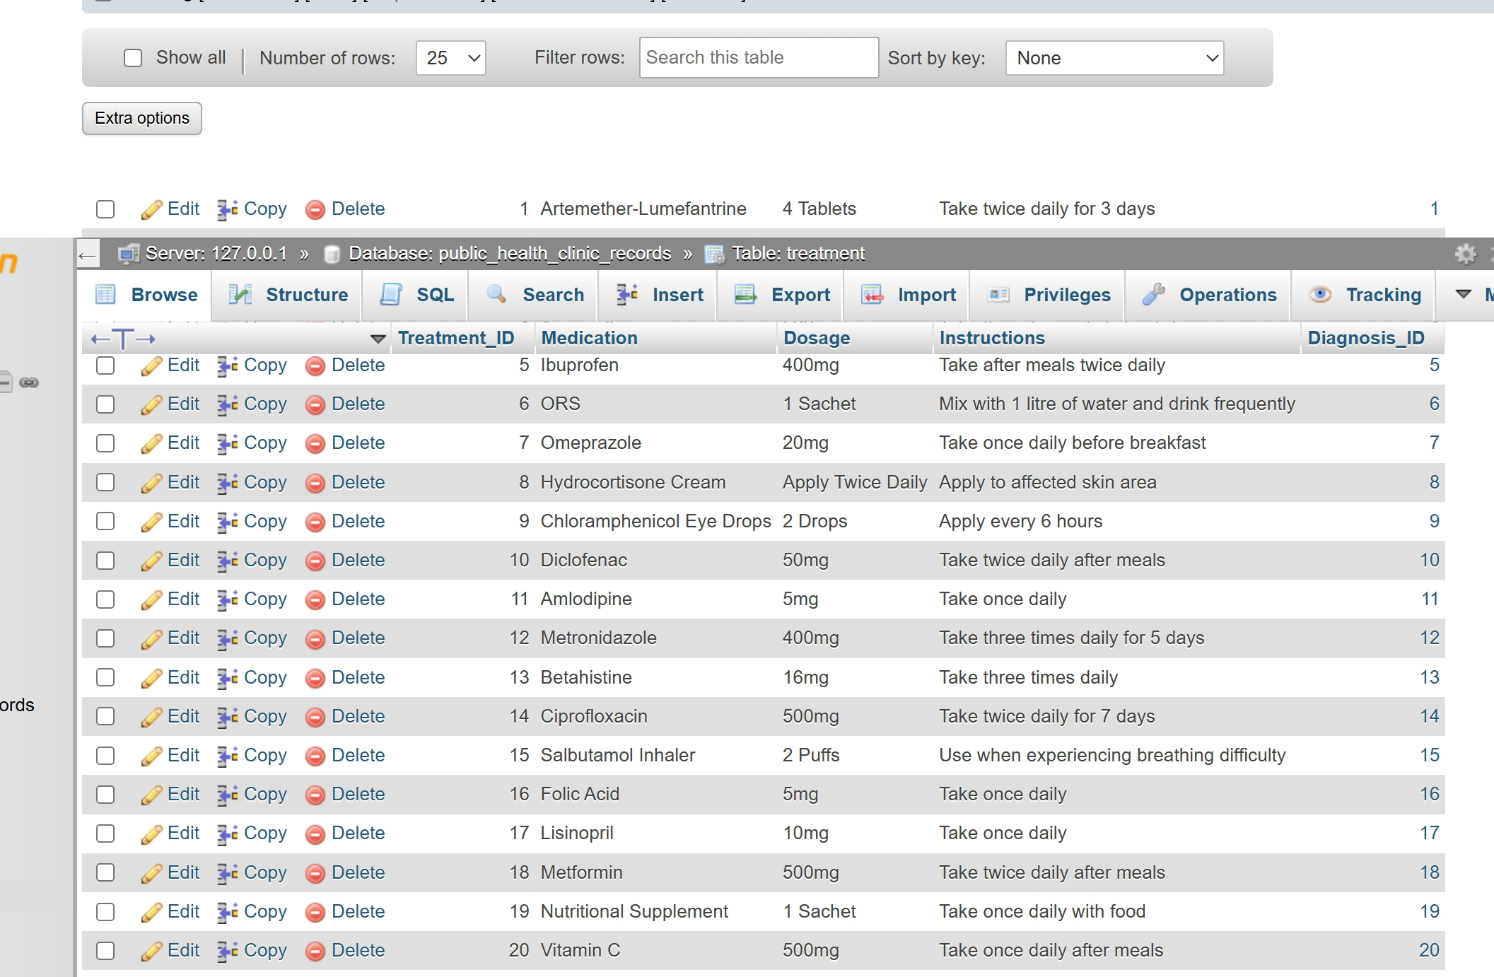

Appointment

Stores appointment records.

Attributes:

- Appointment_ID (Primary Key)
- Appointment_Date
- Appointment_Time
- Patient_ID (Foreign Key)
- Health_Worker_ID (Foreign Key)
- Status

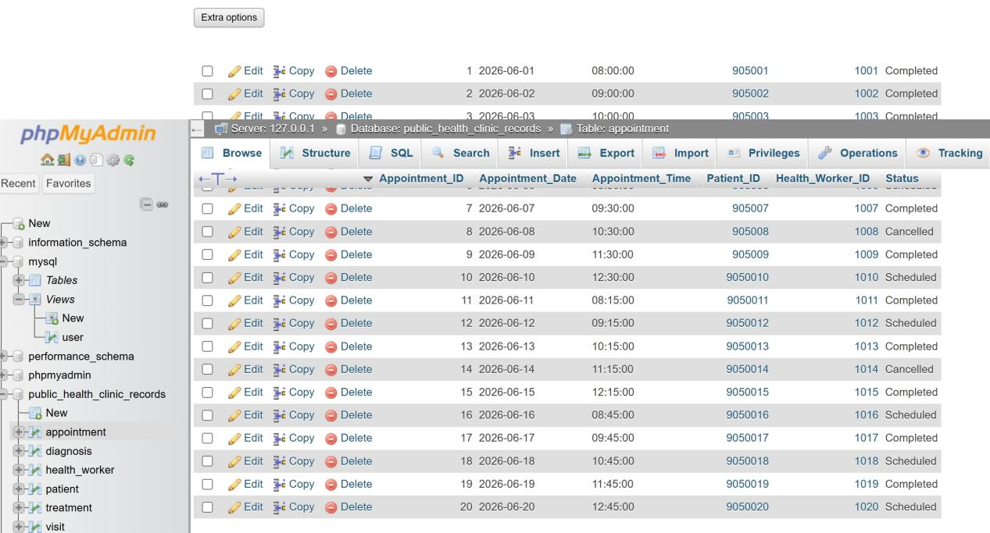

Visit

Stores patient visit records.

Attributes:

- Visit_ID (Primary Key)
- Visit_Date
- Reason
- Patient_ID (Foreign Key)
- Worker_ID (Foreign Key)

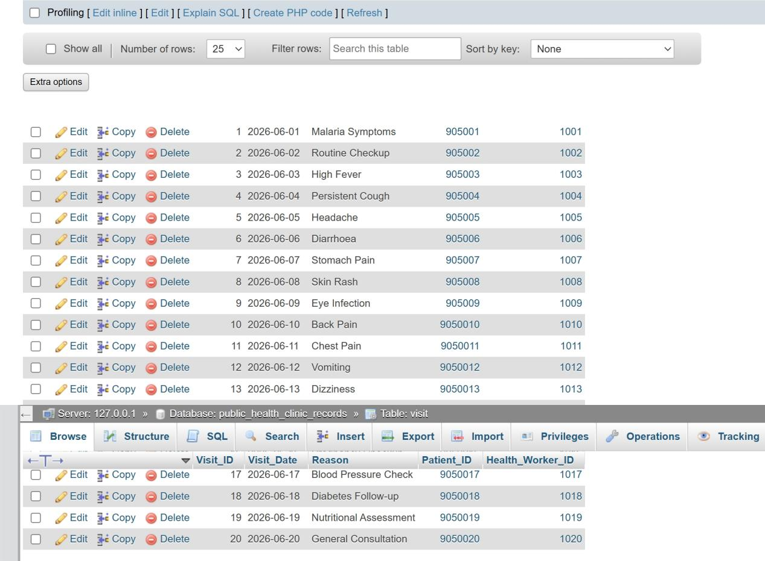

Health_Worker

Stores clinic staff information.

Attributes:

- Worker_ID (Primary Key)
- Name
- Role
- Phone
- Qualification
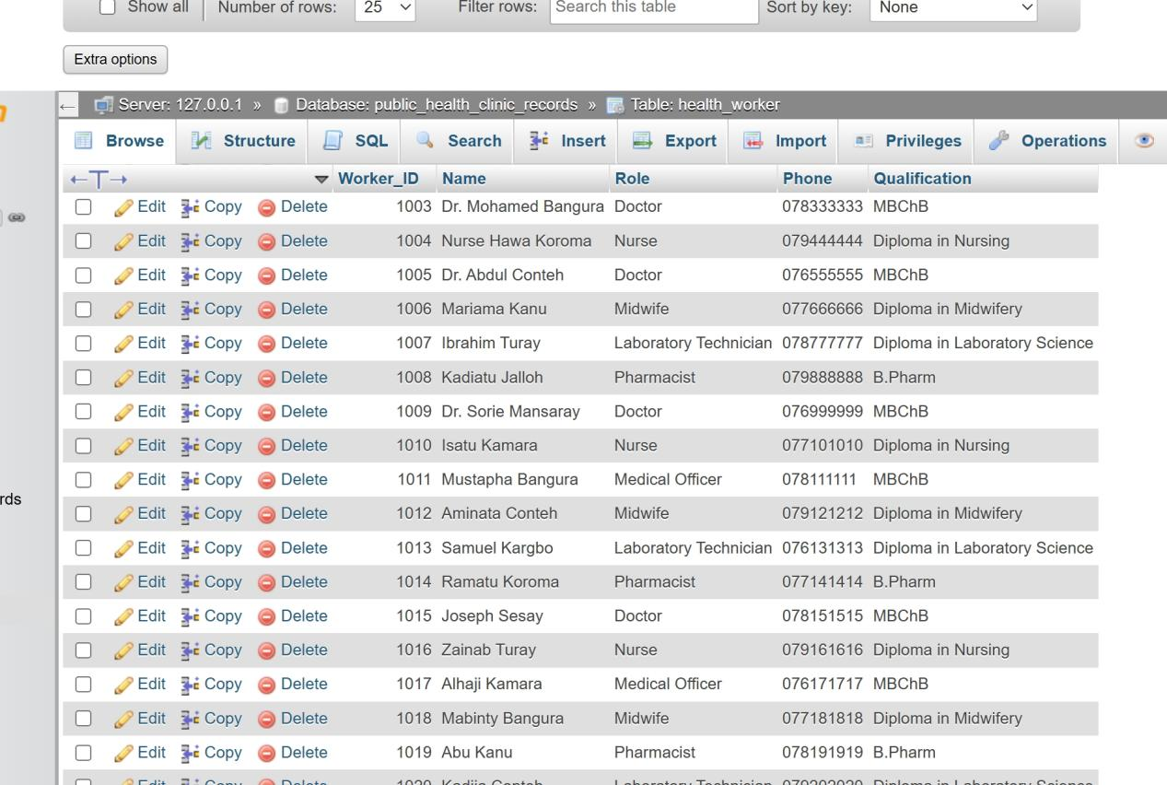

Diagnosis

Stores diagnosis information.

Attributes:

- Diagnosis_ID (Primary Key)
- Diagnosis
- Visit_ID (Foreign Key)
- Result
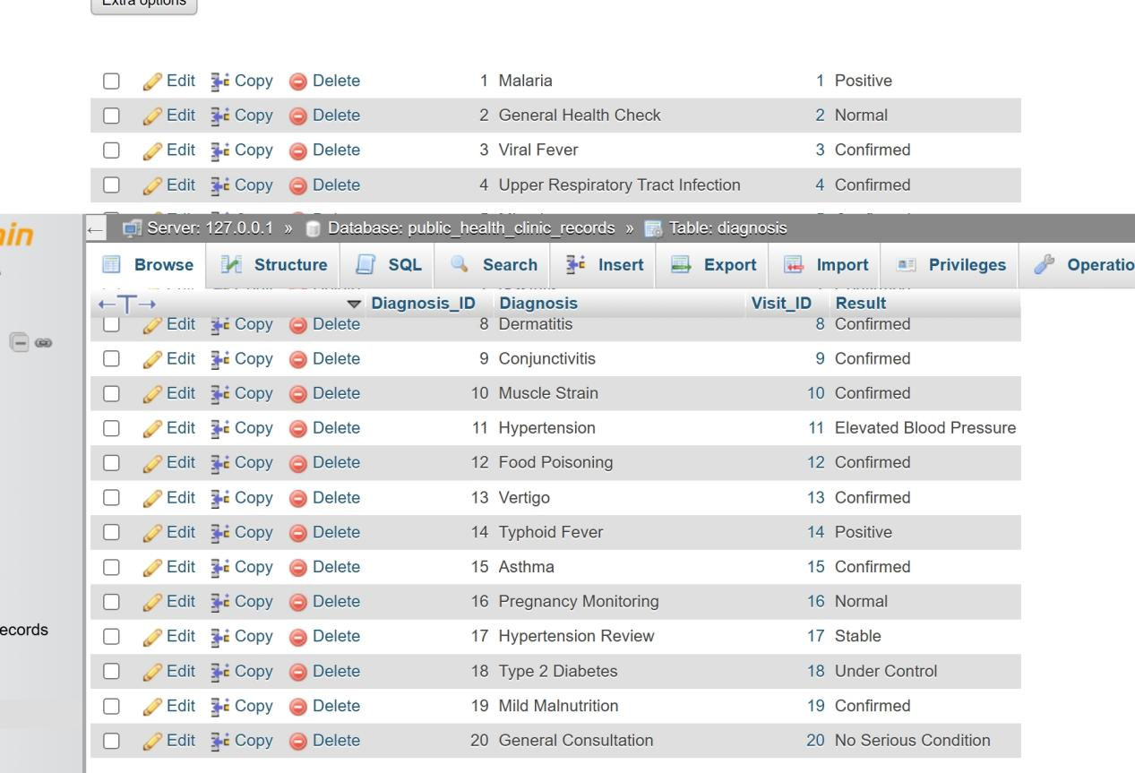

Treatment

Stores treatment records.

Attributes:

- Treatment_ID (Primary Key)
- Medication
- Dosage
- Instructions
- Diagnosis_ID (Foreign Key)



3.3 Relationships

The system contains the following relationships:

- One Patient can have many Visits.
- One Patient can have many Appointments.
- One Health Worker can attend many Visits.
- One Health Worker can handle many Appointments.
- One Visit can have many Diagnoses.
- One Diagnosis can have many Treatments.

4.0 Implementation

4.1 Database Creation

The database was created using MySQL and managed through phpMyAdmin.

Database Name:

Public_Health_Clinic_Records

4.2 SQL Operations Used

The following SQL commands were implemented:

INSERT

Used to add records into tables.

Example:

INSERT INTO Patient
(Name, Date_Of_Birth, Gender, Phone, Address)
VALUES
('John Kamara', '1995-05-12', 'Male', '076999999', 'Freetown');

SELECT

Used to retrieve records.

Example:

SELECT * FROM Patient;

UPDATE

Used to modify existing records.

Example:

UPDATE Patient
SET Phone = '076111111'
WHERE Patient_ID = 905001;

DELETE

Used to remove records.

Example:

DELETE FROM Patient
WHERE Patient_ID = 905001;

5.0 Conclusion and Recommendations

Conclusion

The Public Health Clinic Records System successfully demonstrates the use of relational database concepts in managing healthcare information. The system improves efficiency in storing and retrieving patient data while maintaining data integrity through relationships and constraints.

Recommendations

The following improvements can be made:

- Develop a graphical user interface.
- Implement user authentication.
- Add reporting features.
- Include patient billing functionality.
- Integrate with mobile applications.

REFERENCES

1. Elmasri, R. & Navathe, S. (Database Systems Concepts).
2. MySQL Documentation.
3. phpMyAdmin Documentation.
4. Database Management Systems by Raghu Ramakrishnan.
5. Healthcare Information Systems Research Materials.
6. Database Notes.

